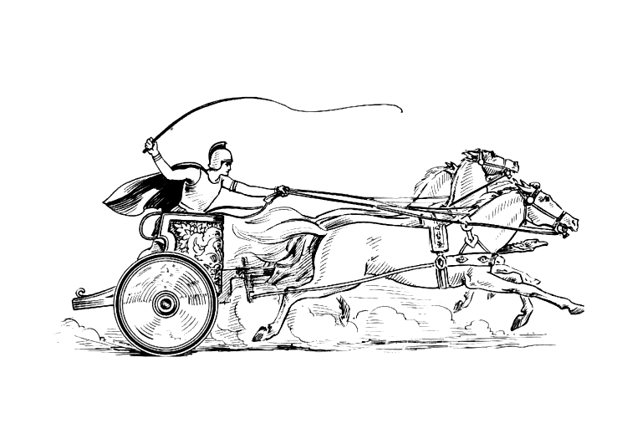 Manduessedum - Mancetter Village (Place of War Chariots)

Mancetter Parish Council
Serving the People of Mancetter and Ridge Lane

EXTRAORDINARY MEETING
OF THE PARISH OF MANCETTER

Minutes of an Extraordinary Meeting of the Parish of Mancetter,
held on Thursday 22nd June 2023 at the Schoolroom
of St Peter’s Church Mancetter,
commencing at 7pm.

Present:
Chairman Mr T Hopkins.

Parish Councillors Mrs G Forknall, Mrs S Healy, Mr P Mann and Mr J Tither

Parish Clerk Mrs E Higgins.

Item 1 - Welcome and Apologies

Mr T Hopkins welcomed everyone to the meeting and noted apologies from Councillor Nicola Wallis.

The main purpose of this meeting was to officially approve the financial information for the Parish Council
following the receipt of the Internal Audit Report as required by legislation.

Item 2 – Recording of the meeting.

There was no recording of the meeting.

Item 3 – Notice of Interest.

There were no notices of interest declared.

Item 4– Public Question Time.

There were no members of the public present at this meeting.

Item 5– Formal receipt of the accounts for 2022 / 2023.

Hard copies of the completed accounts had been received by all councillors prior to the meeting, and no issues were raised as part of the internal audit report.

Subsequently, it was proposed by Mrs S Healy, seconded by Mr P Mann, and approved unanimously, to authorise the accounts for Mancetter Parish Council for the financial year April 2022 to March 2023.

Item 6– Formal signing of section one of the AGAR for 2022 / 2023.

Section One of the Annual Governance and Accountability Return the Annual Governance Statement was approved by all councillors and signed by the Chair and Clerk.

Item 7 – Formal signing of section two of the AGAR for 2022 / 2023.

Section Two of the Annual Governance and Accountability Return the Accounting Statements were approved by all councillors and signed by the Chair and RFO.

Item 8– Updating the Parish Council Bank Mandate.

As a result of the Local Council Elections and the pending retirement of the former Parish Clerk and Proper Officer, Karen Meads, it is necessary to update the bank mandate with HSBC.

Paperwork was prepared and signatures obtained.

Karen Meads will now prepare a letter to accompany the bank mandate for HSBC, confirming her retirement and removal from the bank account.
Elane Higgins the current Parish Clerk, will become the Proper Officer on the new bank mandate.

It will also be necessary to change the mandate for the CCLA Bond.

Item 9 – To review amendments to planning application PAP/2022/506 Canal Cottage Quarry Lane Mancetter.

The Council still feel that it is a large modern dwelling in a historic countryside setting.
They will respect the views of the Heritage Officer and would like to echo that as much of the structure as possible is completed using reclaimed brick from the demolition.
If demolition bricks are unsuitable then could reclaimed bricks of the same size as the original be sourced and used to try and keep the character of the original.

The public footpath AE94 runs directly past the property and the parish council respectfully request that this public right of way remains open and accessible.

Traffic Management is an important consideration throughout the works, due to the entrance being between the main traffic lights over the canal bridge.
Although it does have its own set of lights unlike the numerous developments along the track on the opposite side of the road, Quarry Lane is extremely busy with tarmac contractors and people cutting through the lanes to avoid Nuneaton traffic.

Item 10 – Update on public liability insurance claim in relation to the tree on Mancetter Green.

Due to the disclosure of personal information relating to residents, this agenda item was discussed in accordance with Section 10a(4) of the Local Government Act 1972.

Details of the incident have been submitted to the parish council insurers and the council is working with them to provide any information required. The constant vibration of quarry lorries coupled with high winds and extreme weather conditions has led to the collapse of the tree. It has caused substantial damage to a parked car but fortunately no one was hurt or any property damaged.

The maintenance contractor for the council, who previously worked for the Parks department at Nuneaton and Bedworth Borough Council, regularly mows the area and confirmed that the tree showed no visible signs of distress.

Item 11 – Date of Next Meeting:

Tuesday 25th July 2023 7pm in the Schoolroom, St Peter’s Church Mancetter.

As there was no further business the meeting closed at 8.30pm
Manduessedum - Mancetter Village
(Place of War Chariots)
Mancetter Parish Council
Serving the People of Mancetter and Ridge Lane

